OPM - Bug Fix Assembly - Part 1
Deployment Guide

Revision History
Author | Revision Number | Date
TCSASSEMBLER | 1 | 2/13/2014

Deployment Instructions 3
1. Organization of Submission 3
2. Application Setup 3
3. Ant .Properties File 4
4. Build Scripts Setup 4
5. Database Setup 5
6. Deployment Instructions 6
7. Starting 7
8. Verification 7
8.1. Web Tests 7
8.1. Login 7
8.2. Bug Fixing 8
9. Resource Contact List 36

Deployment Instructions

Organization of Submission

Folder | Description
conf | Contains application configuration files
lib | Contains dependencies (it is empty right now, you should copy from previous contest, see instructions below)
src | Contains all source files
docs | Contains documentation (this file) and the bug list file.
test_files | Contains the test files
log | Contains the test log files
conf/jpa | Contains the JPA mapping and persistence configuration
conf/ejb | Contains the EJB configuration
conf/rules | Contains the business rule definitions
conf/web | Contains the web application configuration files (including spring MVC bean definitions)
conf/ear | Contains application wide configuration (including the datasource definition)
conf/jboss | Contains application changes to the JBoss configuration
src/web | Contains the web application sources
src/java/core | Contains java sources shared across modules
src/java/ejb | Contains java sources for the EJB module
src/java/web | Contains java sources for the front end web application
src/java/tests | Contains java test sources
build-dependencies.xml | Declaration of build dependencies
build.properties | Externalized build configuration
build.xml | Ant build script

Application Setup

The application is tested with the following stack

- Java 6 (http://www.oracle.com/technetwork/java/javase/downloads/index.html)
- JBoss EAP 6.1 (http://www.jboss.org/jbossas/downloads/)
- Ant 1.8.1 (http://ant.apache.org/)
- PostgreSQL 9.2.4 (http://www.postgresql.org/)

The following 3rd party libraries are packaged with the submission
- Drools 5.5
- Jackson 2.3.1
- Spring MVC 3.2.3
- Spring Security 3.1.4
- Hibernate 4.2.3
- Joda-Time 2.3
- JUnit 4.10

Ant .Properties File

Property Name | File property is stored | Example Setting
jboss.home | build.properties | C:/Downloads/jboss-eap-6.1
loggerName | build.properties | gov.opm.scrd
supervisorRoleName | build.properties | supervisor
adminRoleName | build.properties | Admin
defaultPreferenceId | build.properties | 1
defaultReportGenerationDataId | build.properties | 1
log_dir | build.properties | C:/Downloads/opm_log
pendingPaymentStatusIds | build.properties | 2,4,6,8,10,12,14,16,18,20,22,24,26,28
approvedPaymentStatusId | build.properties | 29
disapprovedPaymentStatusId | build.properties | 30
postedPendingApprovalStatus.id | build.properties | 1
postedPendingApprovalStatus. name | build.properties | Posted - Pending Approval
redepositPeriodType.id | build.properties | 1
redepositPeriodType. name | build.properties | Deposit (D)
dedepositPeriodType.id | build.properties | 2
dedepositPeriodType. name | build.properties | Redeposit (R)
csrsRetirementType.id | build.properties | 2
csrsRetirementType. name | build.properties | CSRS
successCalculationStatus.id | build.properties | 1
successCalculationStatus. name | build.properties | Success
opm.drools.rules.directory | build.properties | /bre_assembly/conf/rules
db.driver | build.properties | org.postgresql.Driver
db.url | build.properties | jdbc:postgresql://localhost:5432/scrd
db.user | build.properties | postgres
db.pass | build.properties | 123456

Build Scripts Setup

build.xml – compiles, packages and deploys the application
Main targets:

clean removes all generated files
compile-core compiles shared java sources
compile_tests compiles java test sources
test run the test cases
compile-ejb compiles EJB java sources
compile-war compiles web application java sources
configure-ear performs replacement of values for EAR configuration files
configure-ejb performs replacement of values for EJB configuration files
configure-war performs replacement of values for web app configuration files
db-clear clears the contents of the tables
db-create creates the tables and sequences
db-drop drops the tables and sequences
db-test-data recreates the test data
deploy deploys the EAR artifact
deploy-jdbc-driver copies the jdbc driver module into jboss
dist-core creates the core distribution
dist-ear creates the EAR artifact
dist-ejb creates the EJB distribution
dist-war builds the war file

Default target: deploy

Database Setup

Note: for some steps, you can use the ant script to execute them, but make sure you configure the build.properties first.

- Setup PostgreSQL 9.2.4
- Create the database “scrd” using your client. (You may change the DB name, but update your JDBC URL accordingly)

- Execute script src/sql/create-schema.sql and src/sql/triggers.sql to create the required objects (“ant db-create” will perform the same step)
- Execute script ant “db-test-data” to insert test data

Setup Database Driver module on JBoss

- Copy conf/jboss/modules into the modules folder of your EAP installation -${jboss.home}/modules/system/layers/base (“ant deploy-jdbc-driver” will perform the same step)
- Add the following entry to ${jboss.home}/standalone/configuration/standalone.xml just after the h2 driver declaration on the datasources/drivers subsystem

<driver name="postgresql-jdbc4" module="org.postgresql">
<driver-class>org.postgresql.Driver</driver-class>
</driver>

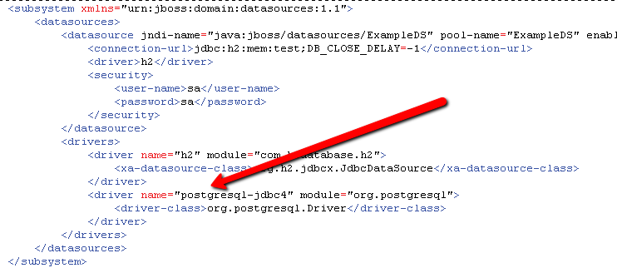

Note: This step can also be done via the jboss command line interface with the following command:

/subsystem=datasources/jdbc-driver=postgresql-jdbc4:add(driver-name=postgresql-jdbc4, driver-class-name=org.postgresql.Driver, driver-module-name=org.postgresql)

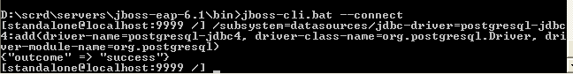

Cleanup scripts: (execute only when done with testing)
• When needed, execute src/sql/clear-data.sql to clear the database tables (“ant db-clear” will perform the same step)
• When needed, execute script src/sql/drop-schema.sql to delete all application objects (“ant db-drop” will perform the same step)

Deployment Instructions

- Modify build.properties to reflect the deployment environment settings. (log_dir must be an existing directory)
- Download OPM SCRD Front End Final Assembly here, and add dependencies in the lib folder, you can download it here part1:http://apps.topcoder.com/wiki/download/attachments/93159486/opm_account_payment_integration_assembly.part1.rar?version=1
part2: http://apps.topcoder.com/wiki/download/attachments/93159486/opm_account_payment_integration_assembly.part2.rar?version=1

- Setup the database as described in the previous section
- Execute “ant deploy”

Starting

Start JBoss. The application is automatically started when the JBoss server is started.

Please note that you may receive a warning (JBAS011054) regarding EAP 6.1 and Spring 3.2.3, you may safely ignore this warning per

https://community.jboss.org/thread/231638?start=0&tstart=0

Verification

Web Tests
When started, open the default URL in your browser http://localhost:8080/scrd/, this should show you the pages.

Note: you may want to turn on DEBUG logging on the server, just add following line to the server configuration (jboss-eap-6.1/standalone/configuration/standalone.xml) under the logging subsystem – make the changes the before starting the server:

<logger category="gov.opm.scrd">
<level name="DEBUG"/>
</logger>

Make sure you change the threshold of the appender to DEBUG too.

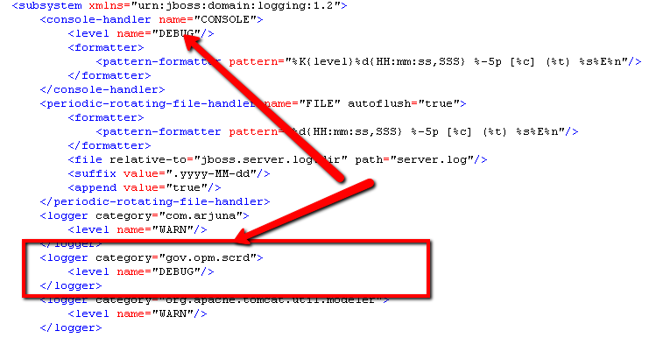

Login
Enter user:user1 and password:123456 to login
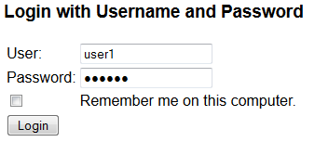

You will be direct to the view account page

Bug Fixing

You can also read the file:
buglist.xls
In that excel file:
YELLOW rows means that the bugs are fixed.
RED rows means that the bugs are final fix issue.
GRAY rows means that the bugs can be ignore.
WHITE rows means that the bugs are not in the scope of this contest.

Or you can read the below information:

OPMBH-464 FIXED
All the “Contact Us” texts are removed from all pages.

OPMBH-465 FIXED
All the “Privacy Policy” texts are removed from all pages.

OPMBH-466 FIXED
All the “Terms & Conditions” texts are removed from all pages.

OPMBH-467 FIXED
All the dummy information bar are removed.
http://apps.topcoder.com/forums/?module=Thread&threadID=810513&start=0

OPMBH-468 FIXED
This bug is fixed, just follow the bug description to verify it.

OPMBH-469 FIXED
This bug is fixed. Just follow the bug description to verify it. No number will be shown until the correct number is retrieved from the server.

OPMBH-470 FIXED
Check: http://apps.topcoder.com/forums/?module=Thread&threadID=810519&start=0
Actually all the pages can used tab. But the style is not correct when the button is focused, now the style is changed when a tab is focus on the button.
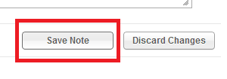

OPMBH-471 FIXED
The table will not show if there are no results. See below:
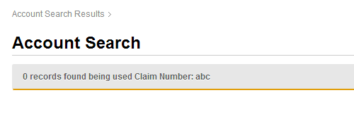

OPMBH-472 FIXED
Check: http://apps.topcoder.com/forums/?module=Thread&threadID=810521&start=0
It will redirect to the account detail.


OPMBH-473 FIXED

See below:
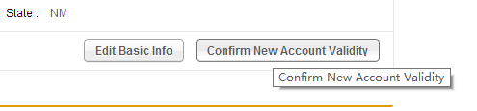

OPMBH-474 IGNORE
http://apps.topcoder.com/forums/?module=Thread&threadID=810523&start=0

OPMBH-475 FIXED
All the date pickers has different titles, see:
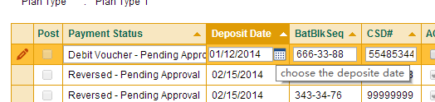

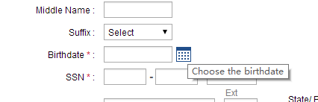

OPMBH-476 FIXED
Check: http://apps.topcoder.com/forums/?module=Thread&threadID=810525&start=0
The pagination is fixed.

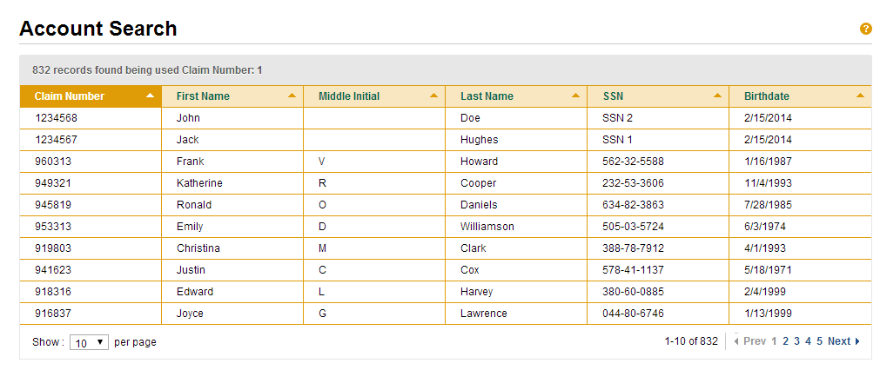

OPMBH-477 FIXED
The user name link is removed

OPMBH-479 FIXED
Please note that most of the dummy data of the status bar are removed. So now only in Approval Page this feature works.

OPMBH-482 FIXED
Just follow the bug description to verify it.

OPMBH-488 IGNORE
I think we can ignore this bug. Because this is a data issue, I think the bug reporter is using the data without the user names. In my version,
The name exists for “Unapproved” and “Approved” tables.
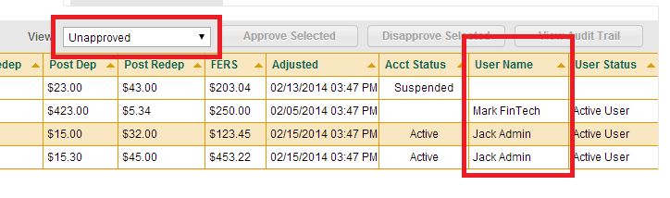
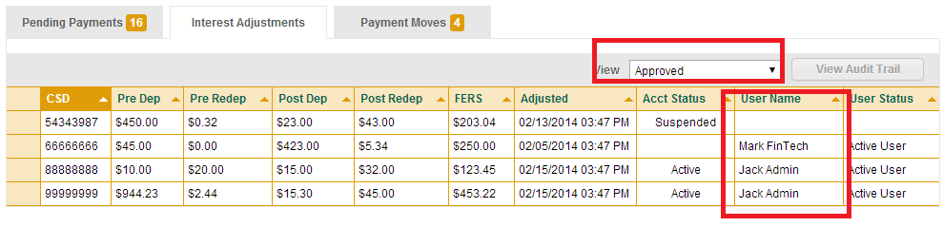

OPMBH-490 FIXED
Just follow the bug description to verify it.

OPMBH-493 FIXED
http://apps.topcoder.com/forums/?module=Thread&threadID=810914&start=0
(Reset your DB data if necessary to verify this item).
Before you can see that:
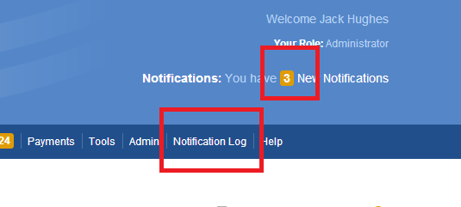

Click the “Notification Log” Tab, you can see that the number will reset to 0, and refresh that page always 0.
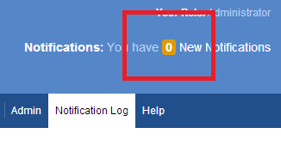

OPMBH-496 IGNORE
http://apps.topcoder.com/forums/?module=Thread&threadID=810913&start=0

OPMBH-499 FIXED
Just follow the bug description to verify it.

OPMBH-502 IGNORE
Check the comments under the bug description that it says to ignore this bug.
OPMBH-504 FIXED
This bug is because the strategy of IE and Chrome about Cache is different. This bug is fixed.

OPMBH-508 FIXED
Just follow the bug description to verify it.

OPMBH-509 FIXED
No table or number are showing when loading:
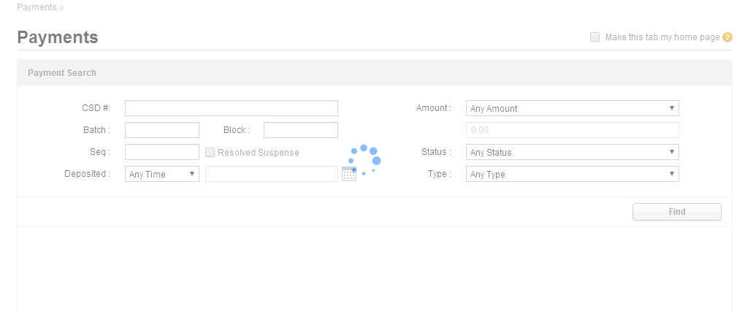

OPMBH-511 FIXED
Just follow the bug description to verify it.

OPMBH-515 FIXED
Just follow the bug description to verify it.

OPMBH-516 FIXED
See below:
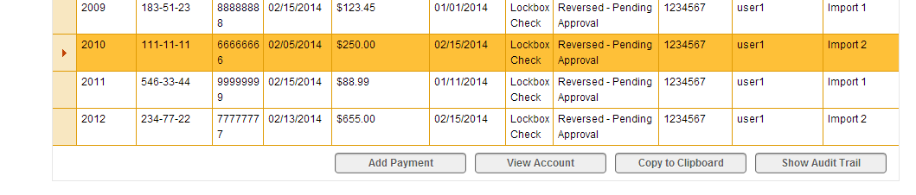

OPMBH-519 FIXED
Now you can use go back on that page or even forward.

OPMBH-521 FIXED
Just follow the bug description to verify it.

OPMBH-523 FIXED
Just follow the bug description to verify it.

OPMBH-530 FIXED
See below:
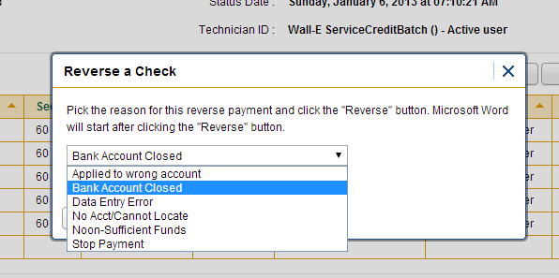

OPMBH-535 IGNORE
The dummy-data status bar is removed because of the previous bugs.

OPMBH-537 FIXED
Then pagination is implemented now:

OPMBH-539 FIXED
Just follow the bug description to verify it.

OPMBH-540 FIXED
Non-numeric characters are not allowed to input.

OPMBH-543 FIXED
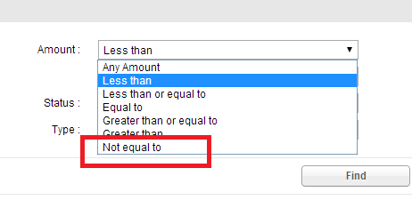

OPMBH-546 FIXED

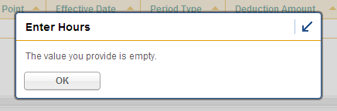

OPMBH-548 FIXED
http://apps.topcoder.com/forums/?module=Thread&threadID=810964&start=0&mc=1#1844029
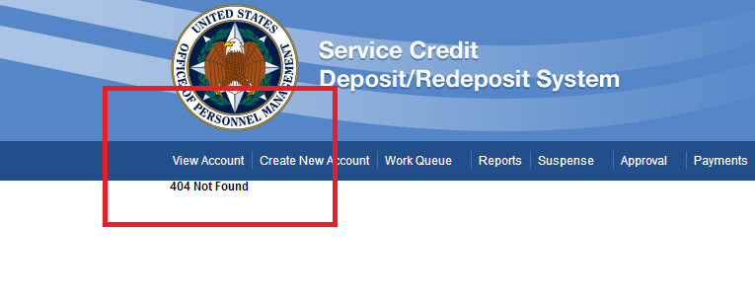

OPMBH-549 FIXED
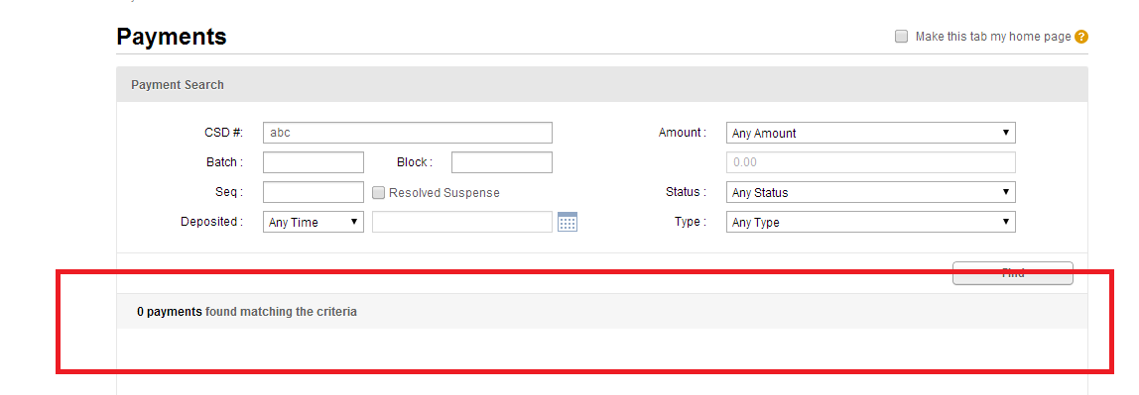

OPMBH-551 FIXED

OPMBH-553 FIXED

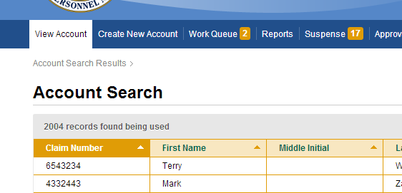

OPMBH-558 FIXED
Loading view is shown.
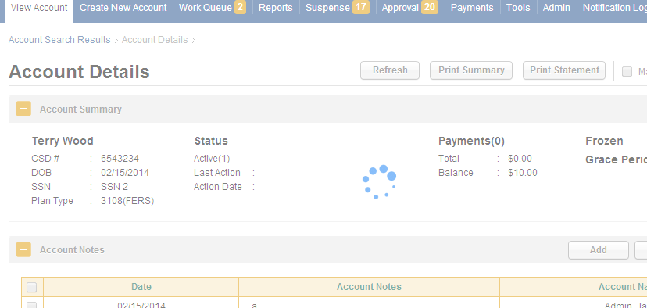

OPMBH-559 FIXED
Just follow the bug description to verify it.

OPMBH-562 FIXED
http://apps.topcoder.com/forums/?module=Thread&threadID=810870&start=0&mc=7#1844136
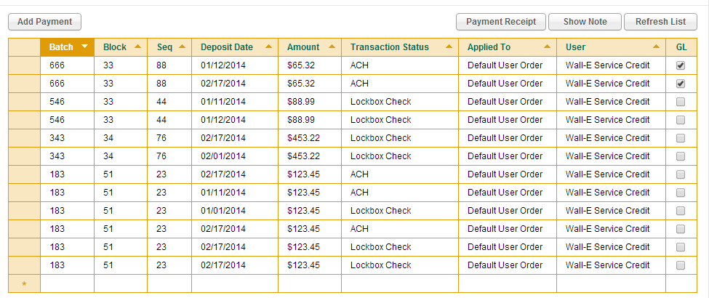

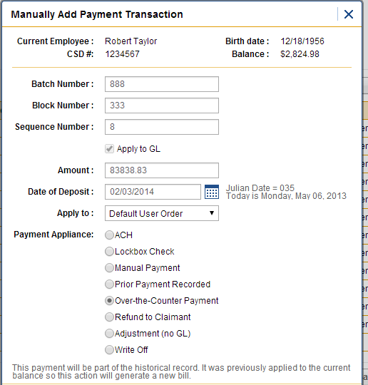

You can see that the data can be added:
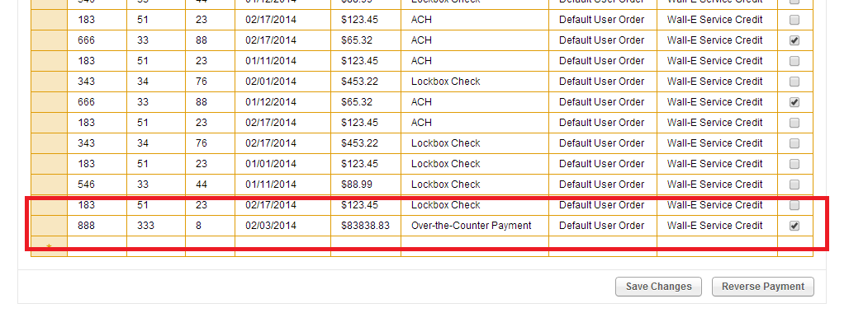

OPMBH-563 FIXED
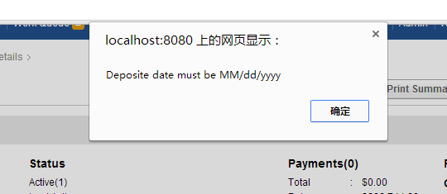

OPMBH-571 FIXED
http://apps.topcoder.com/forums/?module=Thread&threadID=810866&start=0&mc=5#1844224

OPMBH-572 FIXED
http://apps.topcoder.com/forums/?module=Thread&threadID=810866&start=0&mc=5#1844224

OPMBH-573 FIXED
http://apps.topcoder.com/forums/?module=Thread&threadID=810865&start=0
It will refresh the page (via ajax).

OPMBH-574 FIXED
Just follow the bug description to verify it. Remember to click “Save Calculation” and “Refresh Grid” to update the status.
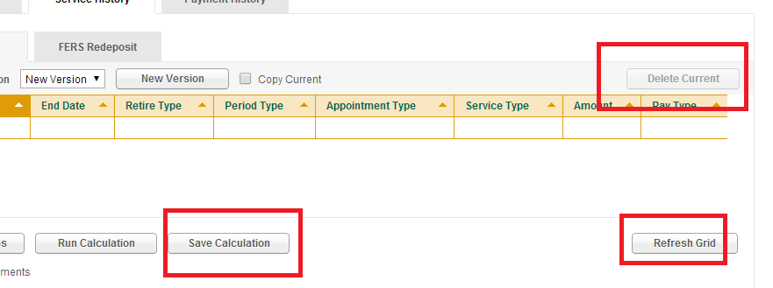

OPMBH-579 CAN’T REPRODUCE
I cannot reproduce this bug, everything seems work well right now.

OPMBH-582 FIXED

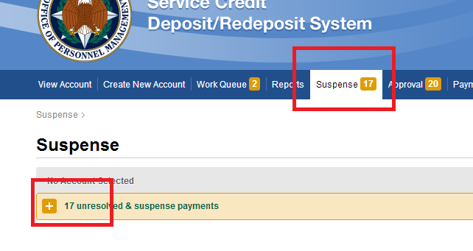

OPMBH-583 FIXED
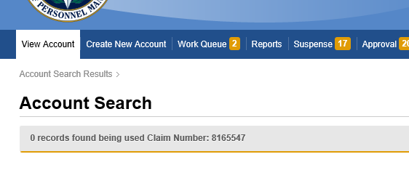

OPMBH-585 FIXED
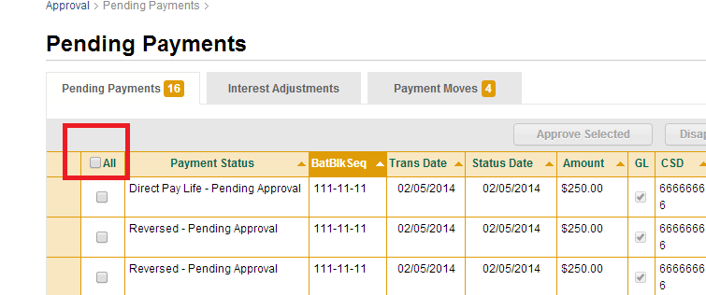

OPMBH-621 IGNORE
http://apps.topcoder.com/forums/?module=Thread&threadID=810844&start=0

OPMBH-623 IGNORE
http://apps.topcoder.com/forums/?module=Thread&threadID=810844&start=0

OPMBH-637 FIXED
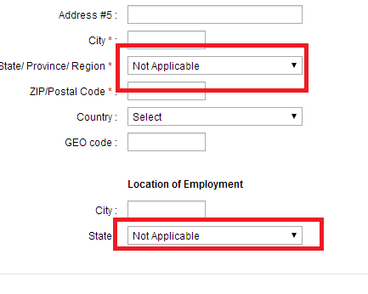

OPMBH-642 FIXED
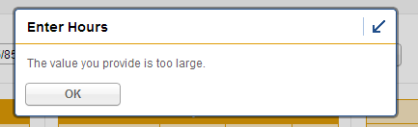

OPMBH-645 FIXED
http://apps.topcoder.com/forums/?module=Thread&threadID=810834&start=0
Always use the creation date.

OPMBH-651 IGNORE
http://apps.topcoder.com/forums/?module=Thread&threadID=810832&start=0&mc=7#1844234

OPMBH-654 FIXED
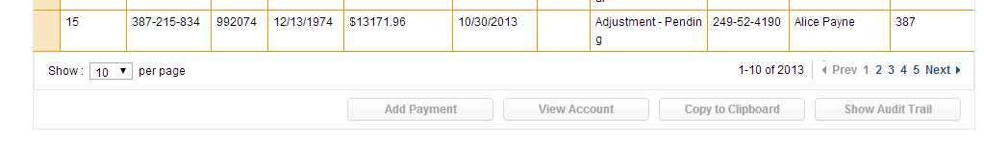

OPMBH-658 FIXED
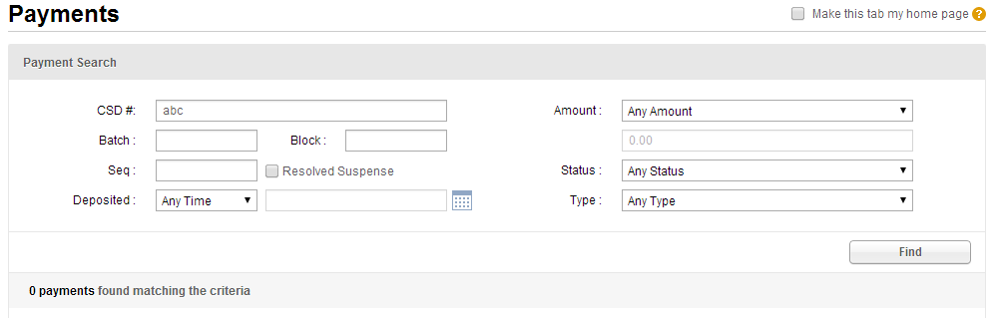

OPMBH-675 FIXED
It is working now: (same as the UI prototype)
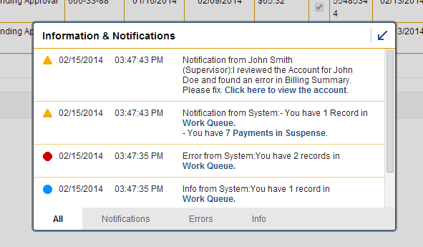

OPMBH-693 FIXED
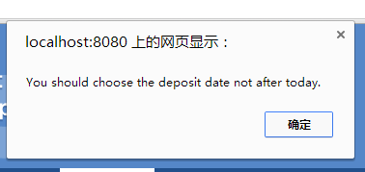

OPMBH-695 FIXED
Just follow the bug description to verify it, there are no random number shows during loading.

OPMBH-698 FIXED
Just follow the bug description to verify it, there are no random number shows during loading.
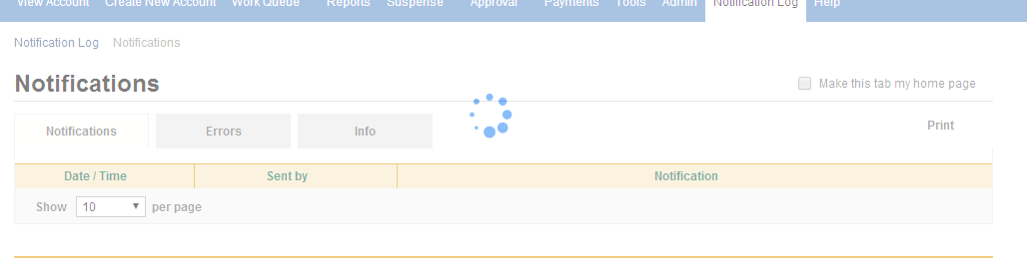
OPMBH-703 CAN’T REPRODUCE

Actually they are using the same font. (You can use chrome web developer tool to verify it).

OPMBH-705 FIXED
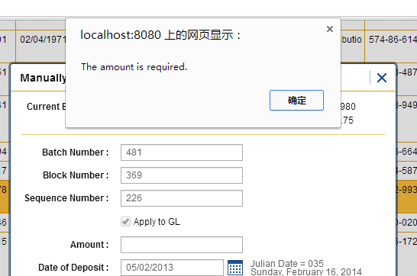

OPMBH-709 FIXED

Batch Number, Block Number and Sequence Number are required now, so that cases will never happen.

OPMBH-710 FIXED
That’s because one of the cell data is too long. This bug is fixed. If you do not have the data of a long cell, you can simply modify it directly on the web page using chrome dev tool. Like:
Before:
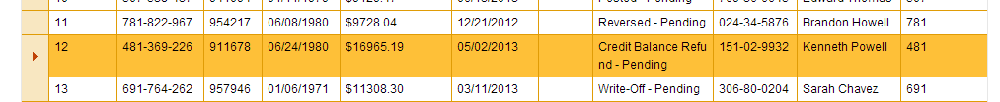
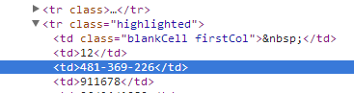
After:
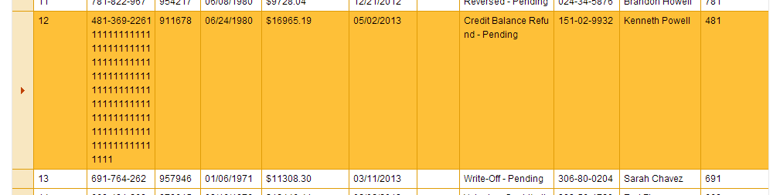

You can see that, for a long cell, the data is properly wrapped, instead of expand the table.

OPMBH-712 FIXED
Just follow the bug description to verify it.
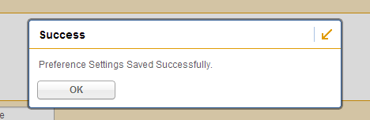

OPMBH-717 FIXED
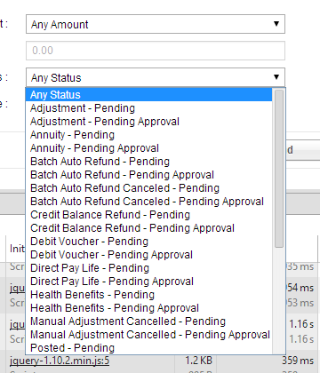

OPMBH-718 FIXED
http://apps.topcoder.com/forums/?module=Thread&threadID=810815&start=0&mc=3#1844248
Make it to alphabet order:

OPMBH-719 FIXED
Non-numeric characters are not allowed to input.

OPMBH-722 FIXED
Dummy status bar are removed according to the previous bugs.

OPMBH-724 FIXED
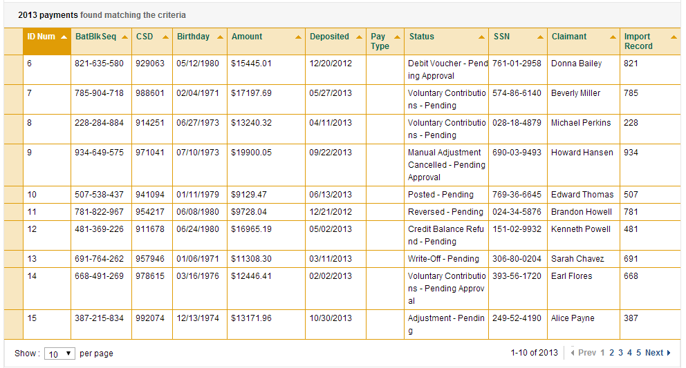

OPMBH-747 FIXED
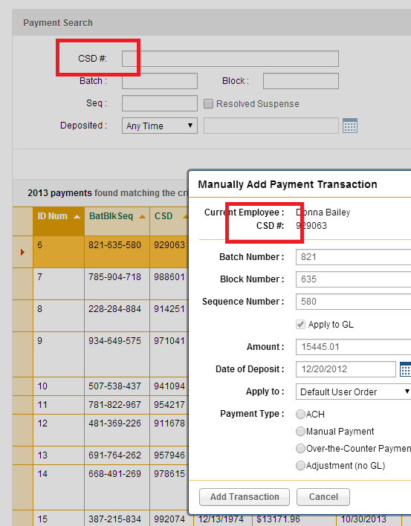

OPMBH-752 FIXED
See below:
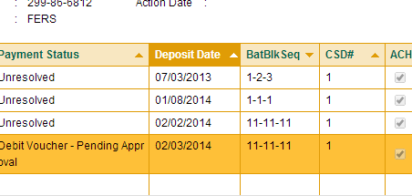

OPMBH-753 FIXED
Similar to bug #752

OPMBH-754 FIXED
Just follow the bug description to verify it.

OPMBH-763 FIXED
Just follow the bug description to verify it.

OPMBH-764 FIXED
Modified to “Clear Filter”

OPMBH-765 FIXED
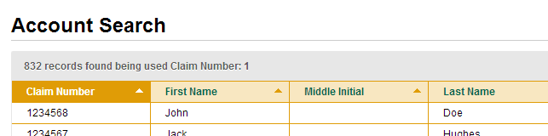

OPMBH-768 FIXED
Just follow the bug description to verify it.

OPMBH-770 FIXED


OPMBH-774 FIXED
This bug happened only in IE, and this bug is fixed. Just follow the bug description to verify it.

OPMBH-778 TO CONFIRM
http://apps.topcoder.com/forums/?module=Thread&threadID=811028&start=0&mc=1#1844272

OPMBH-779 FIXED
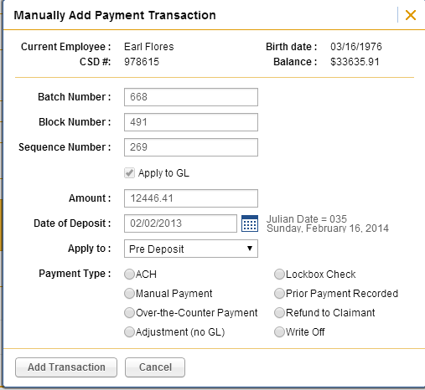

OPMBH-780 FIXED
Just follow the bug description to verify it.

OPMBH-788 FIXED
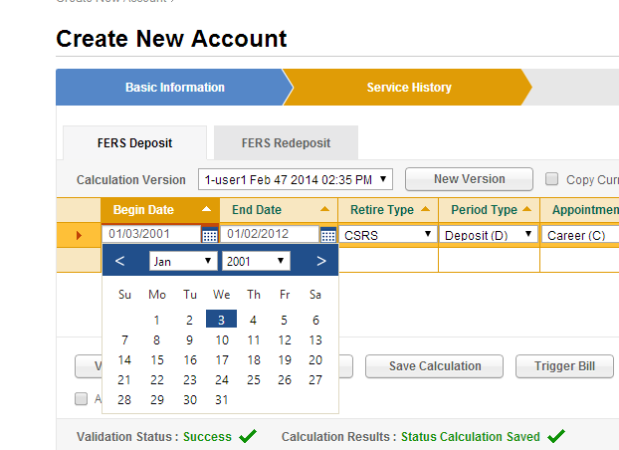

OPMBH-798 FIXED
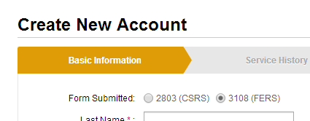

OPMBH-805 FIXED
Just follow the bug description to verify it.

OPMBH-815 FIXED
NOTE, not all of the calculation can be calculated, you can read the rules in csrs_deduction.dslr and fers_deduction.dslr. For example:
The rule
rule "CSRS Firefighter Annual Salary Deposit Calculation"
when
There is a valid Service Period that has retirement type as "CSRS" and has period type as "Deposit (D)" and has pay type as "Annual Salary" and has service type as "Firefighter"
then
Calculate earnings in service period for annual salary
Calculate deduction in service period at deduction rate 0.075
Continue Extended Service Period with no more than 3 days break
End

Then you can choose the retirement type: “CSRS, period type “Deposit (D)”, pay type “Annual Salary”, service type “Firefighter” as follow, and then you can see the result:

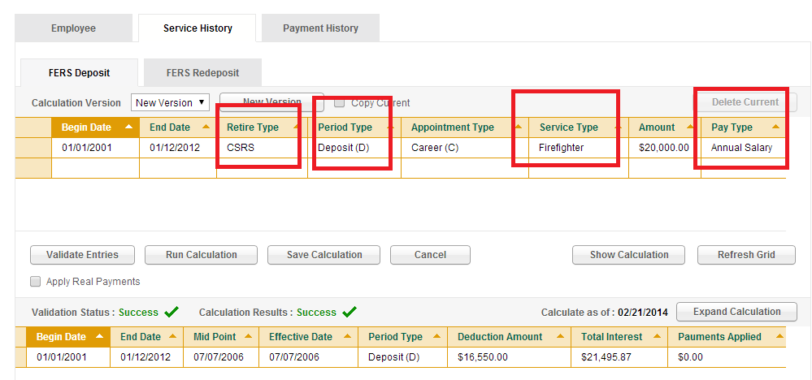

OPMBH-816 FIXED
http://apps.topcoder.com/forums/?module=Thread&threadID=811034&start=0
see OPMBH-815 first.
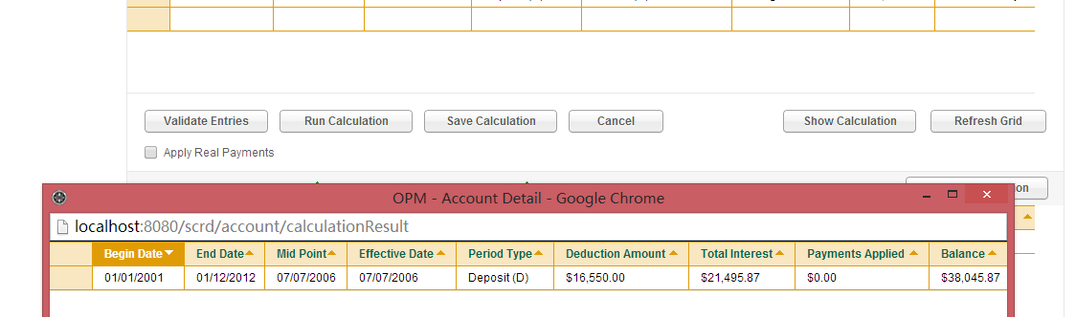

OPMBH-818 IGNORE
http://apps.topcoder.com/forums/?module=Thread&threadID=810764&start=0

OPMBH-823 FIXED
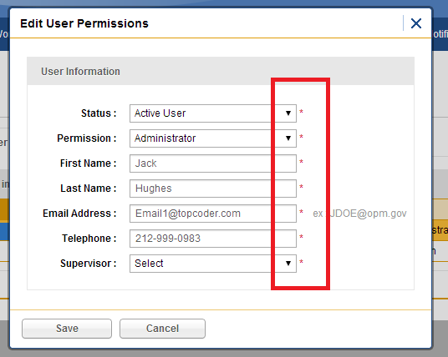

OPMBH-833 FIXED
Just click any date picker to see the source code:
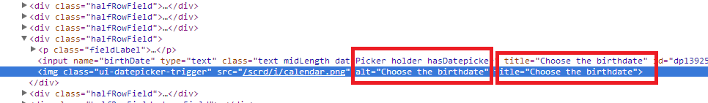

OPMBH-834 FIXED
Just click any date picker to see the source code:

OPMBH-835 FIXED
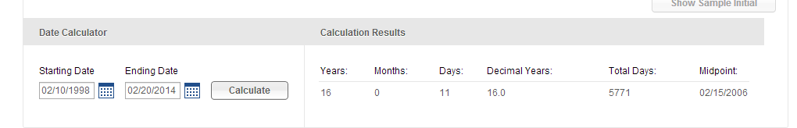

Please note that, according to the algorithm, all the months are consider has and only has 30 days.

OPMBH-852 IGNORE
http://apps.topcoder.com/forums/?module=Thread&threadID=810756&start=0

OPMBH-853 IGNORE
http://apps.topcoder.com/forums/?module=Thread&threadID=810756&start=0

OPMBH-856 FIXED
Just follow the bug description to verify it.

OPMBH-858 IGNORE
This bug is ignore because the dummy status bar is removed.

OPMBH-859 IGNORE
This bug should be ignore (See the comments below the bug description).

OPMBH-860 FIXED
Title attributes are added on this page.
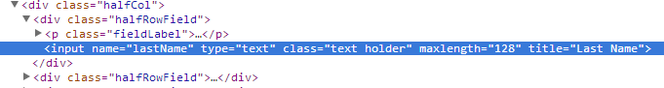

OPMBH-862 FIXED

Hover on the error icon then you can see the error message.
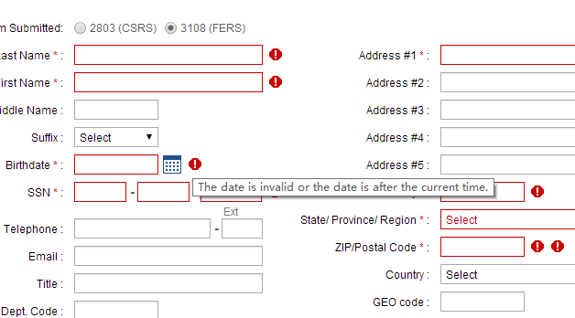

OPMBH-863 FIXED

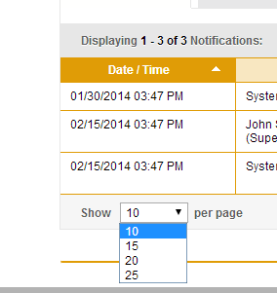

OPMBH-873 FIXED
Just follow the bug description to verify it.

OPMBH-874 FIXED
Just follow the bug description to verify it.

OPMBH-881 IGNORE
This should be ignore according to the comments below the bug description.

OPMBH-888 FIXED
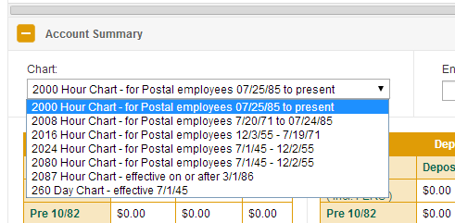

OPMBH-897 FIXED
Just follow the bug description to verify it.

OPMBH-915 FIXED
Just follow the bug description to verify it. The tab only focus on the popup window items.

OPMBH-918 FIXED
Just follow the bug description to verify it.

OPMBH-919 FIXED
Just follow the bug description to verify it.

OPMBH-922 FIXED
Just follow the bug description to verify it. The tab only focus on the popup window items.

OPMBH-923 FIXED
Just follow the bug description to verify it. The tab only focus on the popup window items.

OPMBH-924 FIXED
Just follow the bug description to verify it.

OPMBH-925 FIXED
Just follow the bug description to verify it.

OPMBH-926 FIXED
Just follow the bug description to verify it.

OPMBH-927 FIXED
Just follow the bug description to verify it.

OPMBH-928 FIXED
Just follow the bug description to verify it.

OPMBH-929 FIXED
Just follow the bug description to verify it.

OPMBH-930 FIXED
Just follow the bug description to verify it.

OPMBH-931 FIXED
Just follow the bug description to verify it.

OPMBH-932 FIXED
Just follow the bug description to verify it.

OPMBH-933 FIXED
Just follow the bug description to verify it.

OPMBH-934 FIXED
Just follow the bug description to verify it.

OPMBH-935 FIXED
Just follow the bug description to verify it.

OPMBH-936 FIXED
Just follow the bug description to verify it.

OPMBH-940 FIXED
http://apps.topcoder.com/forums/?module=Thread&threadID=811034&start=0
Duplicated to OPMBH-816

OPMBH-944 FIXED
It will not be refreshing now.

Resource Contact List

Name | Resource Email
TCSASSEMBLER

